How to build Flex environment (As Eclipse plugin)

Prepare:

1. JDK. Make sure it is 32bit.
2. Eclipse. Version: 3.2.2, 3.3, 3.3.2, you can get it from \\wsfscn01\Public\Hugo\flex\eclipse-jee-europa-winter-win32.zip
3. Flex plugin for Eclipse. You can get it from \\wsfscn01\Public\Hugo\flex\FB3_WWEJ_Plugin.exe

Remark: if you have installed JDK, you can specific the JDK version by editing the eclipse.ini

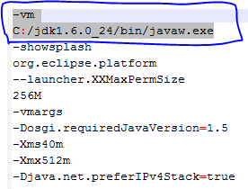

Step to install, please refer to <http://www.smarttutorials.net/how-to-install-adobe-flex-builder-plugin-in-eclipse/>

How to import ActiveNetFlex into Eclipse and debug, please refer to “devhelp.txt”



Any question, please let me know. Hugo.Tian